Relationships, Health and Sex Education (RHSE) Policy for Nether Edge Primary School
1. Rationale and ethos
At Nether Edge Primary School, our vision is to provide children with opportunities, experiences and behaviours that they will need later in life. We aim to encourage children to be open minded, non-discriminative and help develop their sense of morality. Our curriculum inspires children’s self-worth, confidence and curiosity. At the same time, through carefully planned lessons, pupils learn to make informed decisions about their health, wellbeing and relationships with others. The curriculum is delivered proactively, such that it addresses matters in a timely way in line with current evidence on children’s physical, emotional and sexual development.
This policy covers Nether Edge’s approach to relationships, health and sex education (RHSE). These subjects meet statutory obligations as outlined in revised Department for Education statutory guidance (2019). The guidance states that from September 2020, all primary schools must deliver relationships education. At Nether Edge, we are choosing to deliver sex education as part of our RHSE curriculum. This is so that pupils have the opportunity to receive information about sex, at an age appropriate level, before starting secondary school.
Additional requirements on schools in law that have informed this policy and our approach includes the Equality Act (Equality Act 2010: advice for schools) and Keeping Children Safe in Education – Statutory Safeguarding Guidance (2016).
- We define relationships, health and sex education as the building blocks needed for positive and safe relationships, including with family, friends, and online. This includes the importance of treating ourselves and others with kindness, consideration and respect.
- Emotional, social and physical aspects of growing up, relationships, sex and sexuality.
- Lifelong learning about physical, moral and emotional development. It is about the understanding of the importance of friendships and family life, stable and loving relationships, respect, love and care. RHSE is not about the promotion of sexual orientation or activity.
This applies to all areas of pupils’ development and learning. We believe RHS education plays a key part in providing children and young people with the knowledge that enables them to make informed decisions about their wellbeing, health and relationships and to build their self-efficacy. Everyone faces difficult situations in their lives. These subjects can support young people to develop resilience, to know how and when to ask for help, and to know where to access support. Ultimately, helping our young people to be happy, healthy and safe now and in the future.

2. Teaching and Learning
i) Delivery, monitoring and evaluation
Our RHSE programme is an integral part of our whole school PSHE education provision. Biological aspects of RHSE are also taught within the science curriculum. Although specific topics will be addressed, other areas may arise incidentally and will be treated with sensitivity. As part of our PSHE curriculum, the relationships and health education policy is taught for two cycles (20 weeks). The lessons take place each week to ensure children receive a well-rounded education.

Relationships and Health Education Overview
The overview (see below) is also available on our website. Each class has one floor book which provides insight into their work and learning journey.
We have used the guidance from Learn Sheffield when devising our curriculum, taking into account the following principles:
- The school is free to determine, within the statutory curriculum content, what pupils are taught during each year group as outlined in the following document: https://assets.publishing.service.gov.uk/government/uploads/system/uploads/attachment_data/file/908013/Relationships_Education__Relationships_and_Sex_Education__RSE__and_Health_Education.pdf .
- The school always considers the age and development of pupils when deciding what will be taught in each year group.
- The school plans a progressive curriculum, such that topics are built upon prior knowledge taught in previous years as they progress through school to provide a smooth transition to secondary school.
- Although most aspects of the relationships and health education are taught explicitly, some topics are covered in wider subjects such as PSHE, Science and Computing (see appendix).
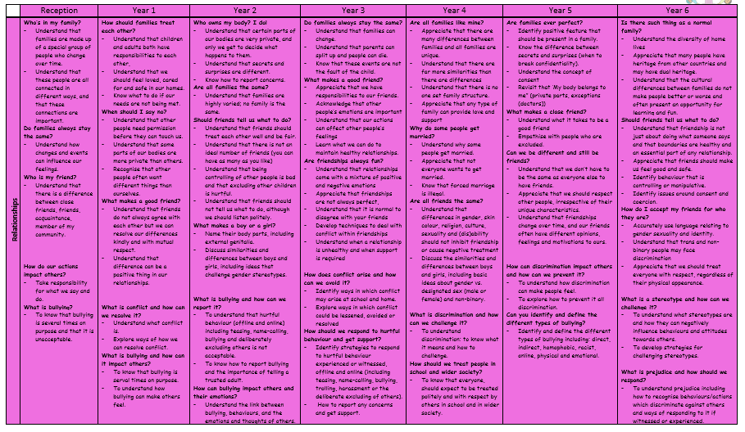

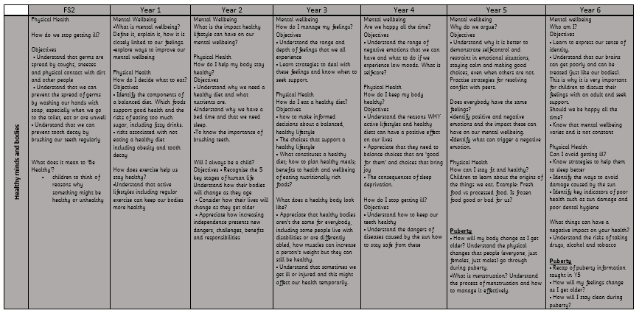

Sex Education
By the end of primary school all pupils must be taught the aspects of sex education outlined in the primary science curriculum. This includes teaching about the main external parts of the human body, how it changes as it grows from birth to old age, including puberty, and the reproductive process in some plants and animals.
All primary schools are free to determine whether pupils should be taught sex education beyond what is required of the National Curriculum. At Nether Edge, we will teach pupils sex education beyond what is required of the National Curriculum. Parents will be fully informed of the sex education content through leaflets and the outline will be made available on the website. The age and development of pupils is always considered when delivering sex education.
This part of the RHSE curriculum is not statutory and therefore parents and carers will have the right to withdraw their child from sex education.
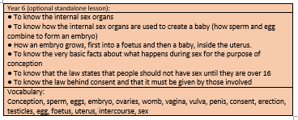

Delivery of the Curriculum
The relationships, health and sex curriculum will be delivered as part of our PSHE curriculum. Through effective organisation and delivery of the subject, we will ensure that:
a. Core knowledge is sectioned into units of manageable size.
b. The required content is communicated to pupils clearly, in a carefully sequenced way, within a planned scheme of work.
c. Teaching includes sufficient and well-chosen opportunities and contexts for pupils to embed new knowledge so that it can be used confidently in real-life situations.
RHSE lessons will be taught by the class teacher. Throughout every year group, appropriate diagrams, videos, books, games, discussion and practical activities will be used to assist learning. Resources will be selected with sensitivity given to the age, developmental stage and cultural background of pupils. Teachers will establish what is appropriate for one-to-one and whole-class settings and alter their teaching of the curriculum accordingly. Teachers will ensure that pupils’ views are listened to and will encourage them to ask questions and engage in discussion. Teachers will answer questions sensitively, honestly and appropriately to the pupil’s age. The curriculum is designed to focus on boys and girls equally, and activities will be planned to ensure both are actively involved, matching their different learning styles. Teachers will focus heavily on the importance on healthy relationships, though sensitivity will always be given as to not stigmatise pupils based on their home circumstances. Teachers will ensure that lesson plans are centred on reducing stigma, particularly in relation to mental wellbeing, and encouraging openness through discussion activities and group work. Teachers will ensure lesson plans focus on challenging perceived views of pupils based on protected characteristics, through exploration of, and developing mutual respect for, those different to themselves. Before delivery of this programme, parents will be consulted, and their views will be valued.
Language and terminology has a vital role to play in helping children develop a vocabulary they can use to communicate comfortably, respectfully and accurately about the human body, growing up, sex and relationships. See the vocabulary list in the appendix. This breaks down scientific vocabulary which will be used by teachers in RHSE lessons.

ii) Inclusivity
All pupils, whatever their experience, background and identity, are entitled to quality RHSE that helps them build confidence, a positive sense of self, and the knowledge understanding to stay safe and healthy. Our school’s RHSE programme is underpinned by a good understanding of pupils’ backgrounds and positive relationships between the school, parents and the local community form the foundations for the teaching of these subjects. We are so lucky to have such a diverse intake of children at Nether Edge, meaning that all classes include pupils with different abilities and aptitudes, experiences, home structures, religious/cultural backgrounds and gender. To encourage pupils to participate in lessons, teachers will ensure content, approach and use of inclusive language reflects the diversity of the school community and helps each and every pupil to feel valued and included in the classroom.
As a school, we will be complying with the relevant provisions of the Equality Act 2010. This includes but is not limited to, awareness and consideration for the protected characteristics. The protected characteristics include disability, religion or belief, cultural diversity, varied family structures, gender and sexual identity. Teaching of the curriculum must reflect requirements set out in law, particularly the Equality Act 2010, so that pupils understand what the law does and does not allow, and the wider legal implications of the decisions they make.
The school ensures that all teaching and materials are appropriate for the ages of the pupils, their developmental stages and any additional needs, such as SEND. Lesson plans will provide appropriate challenge for pupils and be differentiated for pupils’ needs.
Classes may be taught in gender-segregated groups, dependent upon the nature of the topic being delivered at the time, and the cultural background of pupils where it is only appropriate to discuss the body in single gender groups. The statutory guidance states that all pupils, regardless of their gender are taught the facts about menstrual wellbeing in Upper Key Stage 2.
At Nether Edge, we commit to respecting the views and wishes of our diverse communities in a way which does no harm to the other. All learning centres on compassion; teaching our children respect and acceptance of difference, without infringing on the human rights of communities to their religious beliefs or to living their lives freely and openly as LGBT+ people. Our approach to teaching LGBT+ will ensure that this content is fully integrated into the RHSE curriculum, rather than delivered as a standalone lesson. This will be taught with a range of resources, for example: story and picture books aimed at teaching children diversity.

iii) Sensitivity, confidentiality and handling disclosures
We acknowledge that sensitive and potentially difficult issues will arise in RHSE as pupils may naturally share information and ask questions. When spontaneous discussion arises, it is guided in a way that reflects the stated school aims and curriculum content for RHSE. To support a safe learning environment,
∙ Teachers will set the tone by speaking in a matter-of-fact way and be clear what is appropriate and inappropriate in a whole class setting.
∙ Teachers and pupils will agree ground rules by discussion. These will be explained and be visible in the classroom. Teachers will refer back to these rules during discussions as appropriate.
∙ Pupils will be told when they can raise questions verbally. Pupils will also be able to raise questions in writing, this can be anonymously if they wish, by using the question box that is always available in classrooms. This will enable pupils to feel more comfortable to ask questions without being identified. Pupils will be reminded of the question box during lessons.
∙ Teachers will answer pupil questions relating to the taught, planned curriculum for that age group to the whole class.
∙ Staff will have time to prepare answers to all questions before the next session, and will choose not to respond in a whole-class setting to any questions that are inappropriate or need one-to-one follow up.
∙ Teachers will answer questions relating to areas beyond the taught, planned curriculum for that age group, in a sensitive and age appropriate way, only to the pupil or pupils who have asked the question. If a verbal question is too personal, staff will remind the pupils of the ground rules.
∙ If a question is too explicit, feels too old for a pupil, is inappropriate for the whole class, or raises concerns, staff will acknowledge it and promise to attend to it later on an individual basis.
∙ Staff will not provide more information than is appropriate to the age of the pupil. If a member of staff is uncertain about the answer to a question, or indeed whether they should answer it, they will seek guidance from the PSHE leader or Safeguarding Lead. Questions may be referred to parents / carers if it is not appropriate to answer them in school.
∙ Staff training will include sessions on how to deal with difficult questions. Agreed phrases, where appropriate, will be used in response to difficult questions, these can include; ‘That is something that may be covered later on, maybe at a higher year in school.’, ‘I can’t answer that question, but you could ask your parents/carers.’ There may still be times when staff are faced with a difficult question in class that they feel uncomfortable about. In such situations, they may wish to put the question to one side and seek advice from a senior member of staff.
∙ Where a question or comment from a pupil in the classroom indicates the possibilities of abuse or risk of harm, teachers must follow school policy and procedures for safeguarding and child protection.
∙ All staff teaching RHSE will be supported by the designated person for safeguarding and child protection if they have any concerns and the PSHE lead.

iv) Assessment and review of learning
Whilst there are no formal examinations for the relationships, health and sex curriculum, the school and subject leads will monitor the delivery of the RHSE through teacher evaluation of lessons, units and the overall programme/ learning walks/ evidence from lesson observations/ scrutiny of floor book portfolios / evaluation of contributions of external partners. It will also be monitored through feedback and evaluation by pupils. Pupil voice and feedback will be influential in adapting and amending planned learning activities.
Assessment is a process through which judgements are made about an individual’s learning and development. It is not about making judgements on the character, worth or values of individual pupils, nor is it about continual testing. Pupils’ development in RHSE focuses on knowledge as well as skill development and attitudes.
The following are examples of questions that may be used with pupils to support the reflection stage and to develop pupil understanding of what they have learned and the progress they have made.
• What do I know already?
• What new information have I learnt?
• What do I now think and believe?
• How did I feel about what I found out?
• Did I learn anything I did not expect to?
• How will it change my behaviour in the future?
• What do I now need to learn?

3. Roles and Responsibilities
Named member of staff/coordinator for RHSE / PSHE – Olivia Royston and Megan Crew-Meaney
Staff responsible for managing safeguarding and child protection – Michele Nott, Sara Ahmed, Natalie Bradshaw.
Named governor(s) responsible for RHSE – Clive Belgeonne

Governing Body
Overseeing the provision around RHSE is the responsibility of the governing body, who will provide appropriate challenge and agree on the content of this policy. The governing body should liaise with senior leaders to access appropriate training to fulfil the role.

Senior Leaders/Lead members of staff
The lead members of staff will:
∙ Develop this school policy and ensure it is reviewed as per the agreed timetable.
∙ Ensure appropriate training is offered to members of the governing body.
∙ Ensure that all staff are given regular and ongoing training on issues relating to RHSE and how to deliver lessons on such issues.
∙ Ensure that all staff are up to date with the curriculum and its delivery, this policy and any other guidance relating to RHSE.
∙ Provide support to staff members who feel uncomfortable or ill-equipped to deal with the delivery of RHSE to pupils.
∙ Ensure that RHSE is age appropriate and needs-led across all year groups; this means ensuring that the curriculum develops as the pupils do and meets their needs.
∙ Ensure that the knowledge and information regarding RHSE to which all pupils are entitled is provided in a comprehensive way.
∙ Support parent/carer involvement in the development of the RHSE curriculum. Ensure that their personal beliefs, values and attitudes will not prevent them from providing balanced RHSE in school.
∙ Communicate freely with staff, parents/carers and the governing body to ensure that everyone is in understanding of the school policy and curriculum for RHSE, and that any concerns or opinions regarding the provision at the school are listened to, taken into account and acted on as is appropriate.
∙ Ensure that any external sources/visitors are credible, evidence based and enhance learning.

All Staff
Teaching and support staff will:
∙ Ensure that they are up to date with this RHSE policy and curriculum requirements regarding relationships and sex education.
∙ Report back to senior leaders/lead members of staff on any areas that they feel are not covered or inadequately provided for in the school’s RHSE provision.
∙ Attend and engage in professional development training around relationships and sex education provision, when appropriate.
∙ Encourage pupils to communicate concerns regarding their social, personal and emotional development in confidence and listen to their needs and support them seriously.
∙ Follow the school’s reporting systems if a pupil comes to a member of staff with an issue that they feel they are not able to deal with alone.
∙ Will be aware of safeguarding procedures, clear about managing confidentiality and handling disclosures.
∙ Deliver RHSE in a sensitive way ensuring that their personal beliefs and attitudes will not prevent them from providing balanced RHSE in school.
∙ Tailor their lessons to suit all pupils in their class, across the whole range of abilities, faiths, beliefs and cultures, including those pupils with special educational needs, asking for support in this should they need it.
∙ Monitor pupil progress in RHSE.
∙ Respond appropriately to pupils whose parents wish them to be withdrawn from the non-statutory components of RHSE.

Staff do not have the right to opt out of teaching RHSE. Staff who have concerns about teaching RHSE are encouraged to discuss this with the headteacher. It is important that all school staff feel comfortable and confident in planning and delivering RHSE. We will make available regular professional development training in how to deliver relationships, health and sex education. Identification and provision for the continuing professional development (CPD) needs of staff, including non-teaching staff, are described in our Staff training/CPD policy.;

Pupils
Pupils are expected to engage fully in RHSE and, when discussing issues related to RHSE, treat others with respect and sensitivity. Pupils will be given the opportunity to share their views on RHSE, the findings from consulting pupils will be used as a tool for communicating the needs of the children to parents, school staff and governors.

Parents/carers
Nether Edge Primary School recognises the key role parents and carers have in the RHSE of their children. We wish to build a positive and supportive relationship with the parents/carers of children at our school through mutual understanding, trust and co-operation.
To support this parents/carers;
∙ Should be aware that schools are legally required to provide a broad, balanced curriculum.
∙ Can access the schools policies online or request to view hard copies at the school.
∙ Can ask staff questions they may have about the RHSE education of their child.
∙ Will receive information about RHSE so they can support their child’s learning at home.
We believe that, through this mutual exchange of knowledge and information, children will benefit from being given consistent messages about their changing body and their increasing responsibilities.

Health professionals and external visitors can have a valuable role in enhancing the teaching and learning of RHSE. When selecting any external visitors, we will;
∙ Be clear about our reason for working with the visitor.
∙ Ensure visitor selection and presence in school meets requirements of our safeguarding policy and that any visitor is made aware of our policies.
∙ Ensure any visitor is adequately trained and competent and that external input is factually correct, and where relevant there is differentiation between fact and opinion.
∙ Be clear that responsibility for teaching and learning remains with the school.

4. Training
To ensure staff feel confident in teaching the RHSE curriculum:
∙ Staff will be offered generic RHSE guidance; this includes guidance on handling controversial issues, responding to awkward questions, an introduction to the rationale of why teaching RHSE is so important, current law and guidance, learning outcomes and school policy.
∙ Staff involved in the delivery of RHSE issues seen as potentially more sensitive will be offered appropriate training to encourage confidence in dealing with matters of confidentiality, child protection, sensitive issues, and with potentially difficult questions.

5. Community engagement
Our Nether Edge aim is that, every parent/carer will have full confidence in the school’s RHSE programme to meet their child’s needs. As outlined previously, selected resources, such as books and film clips, will be used which support and promote understanding. Parents will have the opportunity to view a select amount of lesson resources on the website.
We will support parents/carers by offering workshops, providing resources and signposting to help parents/carers build their knowledge and confidence of discussing these matters with their children at home to help support their learning.
ii) Right to withdrawal
Parents have the right to request that their child be withdrawn from all of sex education delivered as part of RHSE.
Parents do not have the right to withdraw their child from relationships or health education.
If a parent wishes to have their child withdrawn from sex education, they are required to put the request in writing, addressed to the class teacher. The class teacher will discuss the request with the parents to understand the reasons behind the request. The purpose of the discussion is to clarify the nature and purpose of the curriculum. Class teachers will ensure appropriate alternative work will be given to pupils who are withdrawn from Sex Education.

6. Policy development, monitoring and review
This policy has been developed by all members of the school community including governors, staff, parents and pupils.
The consultation and policy development process involved the following steps:
1. Review – a member of the leadership team pulled together all relevant information including relevant national and local guidance and existing school policies.
2. Consultation – with staff, pupils, parents and governors. The process included parent consultation meetings, themed governor meetings and staff discussions.
3. Ratification – the policy was approved by the full Governing Body on date.
Nether Edge Primary School are committed to monitoring and evaluating the effectiveness of this policy. Specifically, important to the RHSE Programme are:
∙ Pupil feedback,
∙ Staff review and feedback
∙ Parental feedback
∙ Further guidance and legislative changes.

Policy availability
This policy will form part of the induction of all staff members and annual staff training. The Policy is shared on our website. Parents/guardians and all staff members will be notified of any updates. Furthermore, parents and staff are invited to comment on the policy. An easy read version of the RHSE curriculum will be available for parents on the school website.
This policy should be read in conjunction with other school policies, including the Safeguarding Policy, Bullying Policy, Special Educational Needs Policy, PSHE curriculum, Science curriculum and Online Computing Curriculum.
The policy will be reviewed annually.
Policy development date: Last Review Date: Next Review Date:

Appendix
Relationships overview:
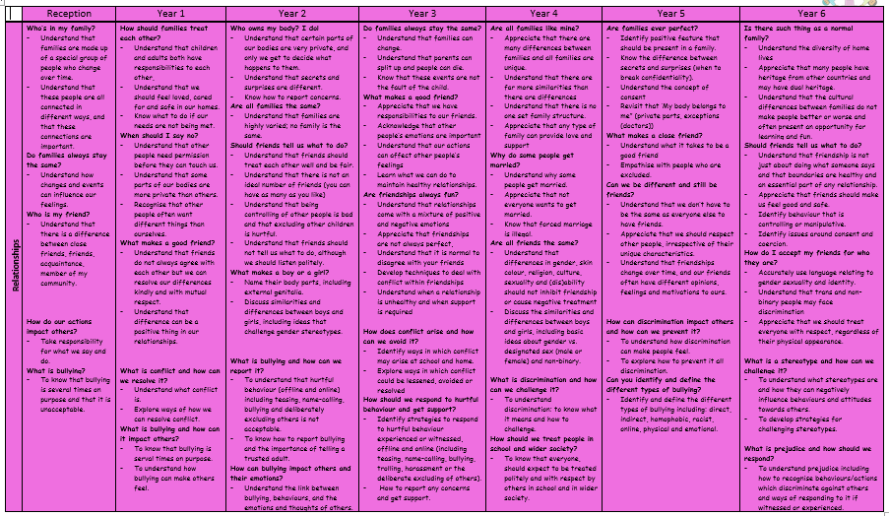
Health overview:
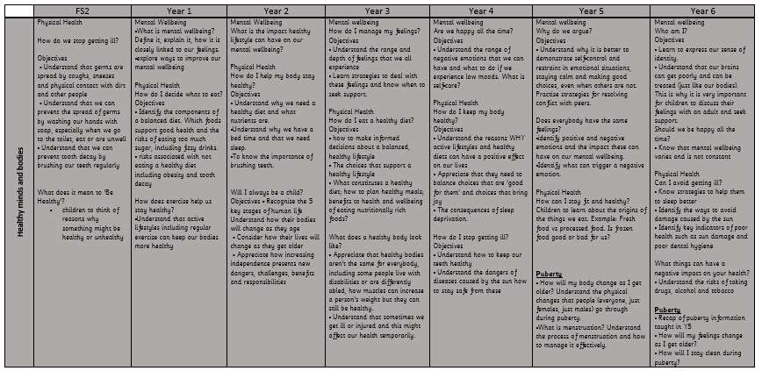

Safe overview:
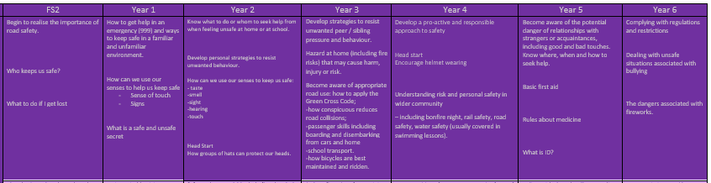
All about me overview:
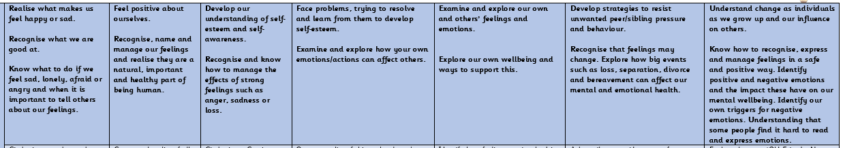

Sex education:
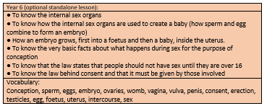

Online safety as part of the computing curriculum:
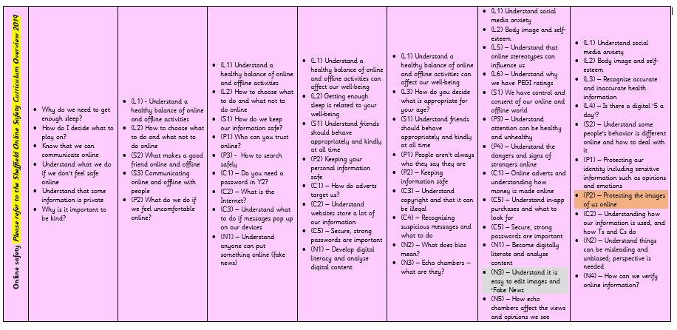

Vocabulary list:
